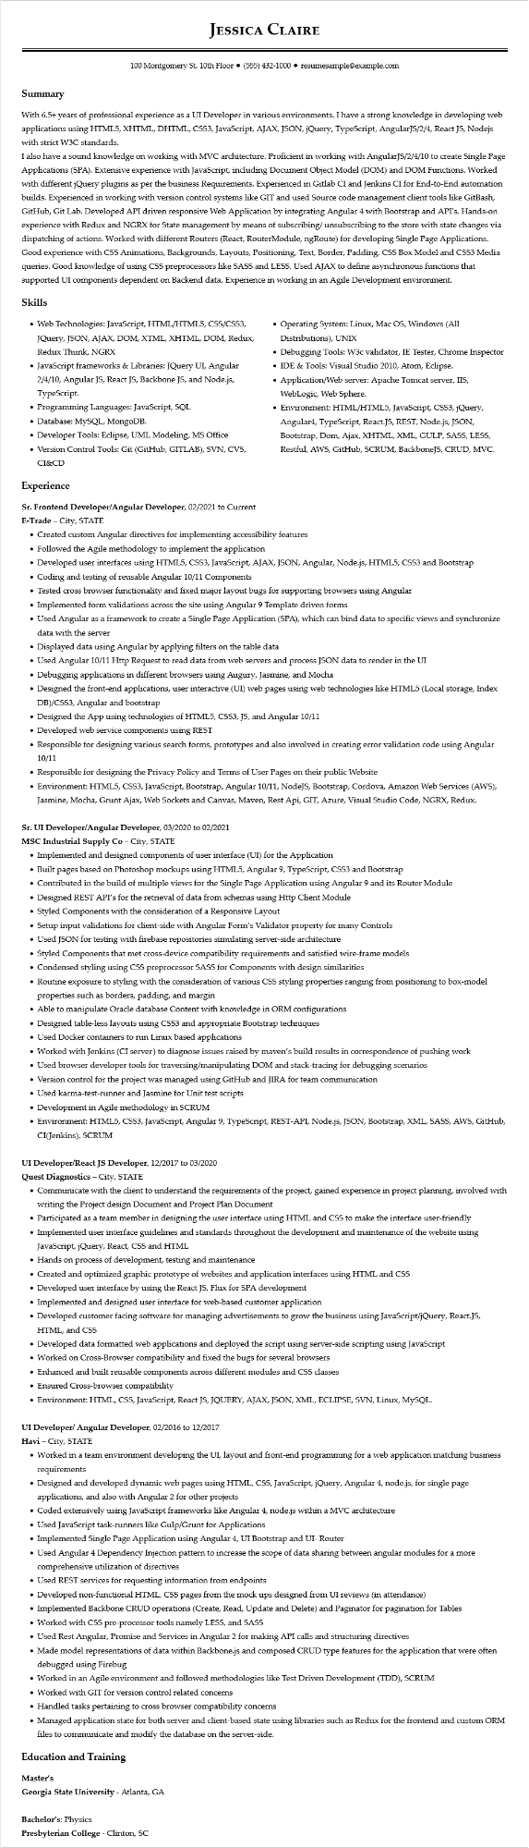
JESSICA CLAIRE
100 Montgomery St. 10th Floor⚫ (555) 432-1000⚫ resumesample@example.com
Summary
With 6.5+ years of professional experience as a UI Developer in various environments. I have a strong knowledge in developing web applications using HTML5, XHTML, DHTML, CSS3, JavaScript, AJAX, JSON, jQuery, TypeScript, AngularJS/2/4, React JS, Nodejs with strict W3C standards.
I also have a sound knowledge on working with MVC architecture. Proficient in working with AngularJS/2/4/10 to create Single Page Applications (SPA). Extensive experience with JavaScript, including Document Object Model (DOM) and DOM Functions. Worked with different jQuery plugins as per the business Requirements. Experienced in Gitlab CI and Jenkins CI for End-to-End automation builds. Experienced in working with version control systems like GIT and used Source code management client tools like GitBash, GitHub, Git Lab. Developed API driven responsive Web Application by integrating Angular 4 with Bootstrap and API's. Hands-on experience with Redux and NGRX for State management by means of subscribing/unsubscribing to the store with state changes via dispatching of actions. Worked with different Routers (React, RouterModule, ngRoute) for developing Single Page Applications. Good experience with CSS Animations, Backgrounds, Layouts, Positioning, Text, Border, Padding, CSS Box Model and CSS3 Media queries. Good knowledge of using CSS preprocessors like SASS and LESS. Used AJAX to define asynchronous functions that supported UI components dependent on Backend data. Experience in working in an Agile Development environment.
Skills
• Web Technologies: JavaScript, HTML/HTML5, CSS/CSS3, JQuery, JSON, AJAX, DOM, XTML, XHTML, DOM, Redux, Redux Thunk, NGRX
• JavaScript frameworks & Libraries: JQuery UI, Angular 2/4/10, Angular JS, React JS, Backbone JS, and Node.js, TypeScript.
• Programming Languages: JavaScript, SQL
• Database: MySQL, MongoDB.
·
Developer Tools: Eclipse, UML Modeling, MS Office
• Version Control Tools: Git (GitHub, GITLAB), SVN, CVS, CI&CD
Experience
Sr. Frontend Developer/Angular Developer, 02/2021 to Current
E-Trade - City, STATE
• Operating System: Linux, Mac OS, Windows (All Distributions), UNIX
• Debugging Tools: W3c validator, IE Tester, Chrome Inspector
• IDE & Tools: Visual Studio 2010, Atom, Eclipse.
• Application/Web server: Apache Tomcat server, IIS, WebLogic, Web Sphere.
• Environment: HTML/HTML5, JavaScript, CSS3, jQuery, Angular4, TypeScript, React.JS, REST, Node.js, JSON, Bootstrap, Dom, Ajax, XHTML, XML, GULP, SASS, LESS, Restful, AWS, GitHub, SCRUM, BackboneJS, CRUD, MVC.
• Created custom Angular directives for implementing accessibility features
• Followed the Agile methodology to implement the application
• Developed user interfaces using HTML5, CSS3, JavaScript, AJAX, JSON, Angular, Node.js, HTML5, CSS3 and Bootstrap
• Coding and testing of reusable Angular 10/11 Components
• Tested cross browser functionality and fixed major layout bugs for supporting browsers using Angular
• Implemented form validations across the site using Angular 9 Template driven forms
• Used Angular as a framework to create a Single Page Application (SPA), which can bind data to specific views and synchronize data with the server
• Displayed data using Angular by applying filters on the table data
• Used Angular 10/11 Http Request to read data from web servers and process JSON data to render in the UI
• Debugging applications in different browsers using Augury, Jasmine, and Mocha
• Designed the front-end applications, user interactive (UI) web pages using web technologies like HTML5 (Local storage, Index DB)/CSS3, Angular and bootstrap
• Designed the App using technologies of HTML5, CSS3, JS, and Angular 10/11
• Developed web service components using REST
• Responsible for designing various search forms, prototypes and also involved in creating error validation code using Angular 10/11
• Responsible for designing the Privacy Policy and Terms of User Pages on their public Website
• Environment: HTML5, CSS3, JavaScript, Bootstrap, Angular 10/11, NodeJS, Bootstrap, Cordova, Amazon Web Services (AWS), Jasmine, Mocha, Grunt Ajax, Web Sockets and Canvas, Maven, Rest Api, GIT, Azure, Visual Studio Code, NGRX, Redux.
Sr. UI Developer/Angular Developer, 03/2020 to 02/2021
MSC Industrial Supply Co - City, STATE
• Implemented and designed components of user interface (UI) for the Application
• Built pages based on Photoshop mockups using HTML5, Angular 9, TypeScript, CSS3 and Bootstrap
• Contributed in the build of multiple views for the Single Page Application using Angular 9 and its Router Module
• Designed REST API's for the retrieval of data from schemas using Http Client Module
• Styled Components with the consideration of a Responsive Layout
• Setup input validations for client-side with Angular Form's Validator property for many Controls
• Used JSON for testing with firebase repositories simulating server-side architecture
• Styled Components that met cross-device compatibility requirements and satisfied wire-frame models
• Condensed styling using CSS preprocessor SASS for Components with design similarities
• Routine exposure to styling with the consideration of various CSS styling properties ranging from positioning to box-model properties such as borders, padding, and margin
• Able to manipulate Oracle database Content with knowledge in ORM configurations
• Designed table-less layouts using CSS3 and appropriate Bootstrap techniques
• Used Docker containers to run Linux based applications
• Worked with Jenkins (CI server) to diagnose issues raised by maven's build results in correspondence of pushing work
• Used browser developer tools for traversing/manipulating DOM and stack-tracing for debugging scenarios
• Version control for the project was managed using GitHub and JIRA for team communication
• Used karma-test-runner and Jasmine for Unit test scripts
• Development in Agile methodology in SCRUM
• Environment: HTML5, CSS3, JavaScript, Angular 9, TypeScript, REST-API, Node.js, JSON, Bootstrap, XML, SASS, AWS, GitHub, CI(Jenkins), SCRUM
UI Developer/React JS Developer, 12/2017 to 03/2020
Quest Diagnostics - City, STATE
• Communicate with the client to understand the requirements of the project, gained experience in project planning, involved with writing the Project design Document and Project Plan Document
• Participated as a team member in designing the user interface using HTML and CSS to make the interface user-friendly
• Implemented user interface guidelines and standards throughout the development and maintenance of the website using JavaScript, jQuery, React, CSS and HTML
• Hands on process of development, testing and maintenance
• Created and optimized graphic prototype of websites and application interfaces using HTML and CSS
• Developed user interface by using the React JS, Flux for SPA development
• Implemented and designed user interface for web-based customer application
• Developed customer facing software for managing advertisements to grow the business using JavaScript/jQuery, React.JS, HTML, and CSS
• Developed data formatted web applications and deployed the script using server-side scripting using JavaScript
• Worked on Cross-Browser compatibility and fixed the bugs for several browsers
• Enhanced and built reusable components across different modules and CSS classes
• Ensured Cross-browser compatibility
• Environment: HTML, CSS, JavaScript, React JS, JQUERY, AJAX, JSON, XML, ECLIPSE, SVN, Linux, MySQL.
UI Developer/ Angular Developer, 02/2016 to 12/2017
Havi - City, STATE
• Worked in a team environment developing the UI, layout and front-end programming for a web application matching business
requirements
• Designed and developed dynamic web pages using HTML, CSS, JavaScript, jQuery, Angular 4, node.js, for single page applications, and also with Angular 2 for other projects
• Coded extensively using JavaScript frameworks like Angular 4, node.js within a MVC architecture
• Used JavaScript task-runners like Gulp/Grunt for Applications
• Implemented Single Page Application using Angular 4, UI Bootstrap and UI- Router
• Used Angular 4 Dependency Injection pattern to increase the scope of data sharing between angular modules for a more comprehensive utilization of directives
• Used REST services for requesting information from endpoints
• Developed non-functional HTML, CSS pages from the mock ups designed from UI reviews (in attendance)
• Implemented Backbone CRUD operations (Create, Read, Update and Delete) and Paginator for pagination for Tables
• Worked with CSS pre-processor tools namely LESS, and SASS
• Used Rest Angular, Promise and Services in Angular 2 for making API calls and structuring directives
• Made model representations of data within Backbone.js and composed CRUD type features for the application that were often debugged using Firebug
• Worked in an Agile environment and followed methodologies like Test Driven Development (TDD), SCRUM
• Worked with GIT for version control related concerns
• Handled tasks pertaining to cross browser compatibility concerns
• Managed application state for both server and client-based state using libraries such as Redux for the frontend and custom ORM
files to communicate and modify the database on the server-side.
Education and Training
Master's
Georgia State University - Atlanta, GA
Bachelor's: Physics
Presbyterian College - Clinton, SC

